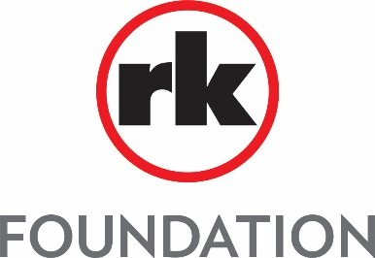

Grant Progress Report

Per the Grant Application Guidelines of the RK Foundation, funding recipients must submit a progress report within twelve (12) months of receiving a grant. Please utilize the basic format below to complete the progress report and email to Katie Dell at katie@rk-foundation.org. Please call (303) 785-6782 with any questions and thank you.

Organization Information
Organization Name:
EIN:
Contact Name:
Contact Title:
Address:
Phone:
E-mail:

Mission and Goals of Organization

Brief History of Organization

Funded Project / Program

Grant Date / Timeframe

Progress Report / Grant Impact Status

